Social Implications: Plagiarism
si_plagiarism.php — Social Implications

Plagiarism

"This is my work - NOT!"
Plagiarism is claiming someone else's idea(s) as your own and presenting someone else's IP as your own work
Plagiarism is most common in academic environments, school, publishing and in the music industry.
Plagiarism can have very serious consequences - people who have plagiarised other's work have lost their jobs, lost their Academic Degrees, had to pay large fines - and even been sent to jail!
[image unavailable: Copyright symbol made up from words.]
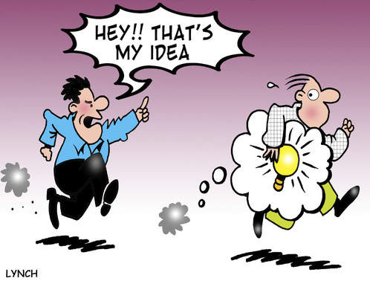
Cartoon licensed and used with permission from Mark Lynch

To prevent being accused of plagiarism you need to:
Record your sources when you research.
Credit your sources in a bibliography.
Put direct quotes from a source in quotation marks.
Ensure no more than 10% of your report / document is made up of quotes / ideas from other sources.
To prevent yourself being tempted to copy and paste work from the internet you need to manage your time. If you are trying to cram what should be 2 week's worth of work into one night because your project is due tomorrow - then of course you will be tempted to plagiarise - especially because the time pressure is so great and it is so easy to cut and paste!
At University the rules about plagiarism are usually 0 (zero) for the task on the first offence, 0 (zero) for the course on the second offence and expulsion on the third offence!

Video Links - Copyright, Copyleft, Piracy and EULAs
We have selected and curated a set of videos on YouTube related to your course.
These videos are not created or owned by us.
They may display advertising and in some cases may contain limited amounts of swearing.

Notes for this Module
What to look out for and do in this module...
The FAQs are not questions that are likely to appear in exam papers - they are real questions that most people ask about the content.
If you plagiarise at school (especially if you get away with it (shame on your teachers if that happens) then you are more likely to do it again later in life - when you are an adult and the consequences can be much more severe.
Just don't do it!

FAQs for this module
Questions on Plagiarism - and their answers...

Network Types FAQ
View the questions or type in the term you are looking for below…
No results were found

What's the big fuss about? Everybody copies, don't they?
Ideas are worth money. Even more so in today's world where information is power.
Stealing ideas is theft.
Publishing a book, picture, cartoon, movie - anything that you earn money from where you have stolen someone else's idea is theft.
Stealing someone else's ideas in academic work allows you to get credit, prestige, respect and possibly even a job that you do not deserve.
Plagiarism is bad - don't do it at school because that will help you to get into the habit of not doing it later in life.

If I change some words is that ok?
No. That is paraphrasing.
It is better to find an appropriate quote from your source. Include the quote (with quotation marks) and credit your source in your bibliography.
Then you write what you think about the quote - whether you agree or disagree - what you think should be different, etc.
Using someone else's idea or argument as a starting point - or as facts / statistics to back up your own work is not a problem.
BUT: you have to give credit and think for yourself!

How much quoting can I do?
No more than 10% of your final product can be someone else's work.
So no, you cannot create a whole report made up of quotes from other people even if you put them in quotation marks and give proper credit in your bibliography!

What if I re-use my own work?
That is self-plagiarism.
You are in Grade 11 and you hand in a project you did in grade 10 at your old school …
You have just plagiarised yourself.
This can have severe consequences in the adult world.
Don't do it!

Is it possible to accidentally plagiarise someone?
It is more likely in visual arts - cartoonists drawing something from a similar perspective is an example.
Accidental plagiarism is almost impossible in text.
If it looks like plagiarism, it probably is.
The person accused of plagiarism would have to prove that they had not seen the original work (which is hard to do).

